LAB EXPERIMENTS
NAME: Y.SAI PRASANTH VARMA REGISTRATION NUMBER:192411191
COURSE NAME: INTERNET PROGRAMMING
COURSE CODE: CSA4308

6. The online cake ordering system allows users to browse a variety of cakes by category, flavor, and occasion, complete with detailed descriptions and images. Users can register, log in, and manage their orders through a personal dashboard. The ordering process includes selecting a cake, customizing options like size and message, entering delivery details, and making secure payments via an integrated payment gateway. Admins can manage cake inventory, track orders, and handle user accounts through an admin panel. Users receive order confirmation emails and can track delivery status. The website is fully responsive, providing a seamless shopping experience on all devices. Buy a Cake is a portal which allows admin in developing counters to advertise and sell their cake. This would permit rural communities to make their wares available to the rest of the world. The proposed system is to develop the website for cake store. User can buy the nearby cake available in app. An E Com App is a portal which allows admin in developing products to promote and sell their goods. This would permit rural communities to make their wares available to the rest of the world.
Source Code:
<!DOCTYPE html>
<html lang="en">
<head>
<meta charset="UTF-8">
<meta name="viewport" content="width=device-width, initial-scale=1.0">
<title>Sweet Cake Online Ordering</title>

<style>
*{
margin:0
padding:0;
box-sizing:border-box;
font-family:Arial, sans-serif;
}

body{
background:#fff8f9;
}

header{
background:#c2185b;
color:white;
text-align:center;
padding:25px;
}

nav{
background:#880e4f;
text-align:center;
padding:15px;
position:sticky;
top:0;
}

nav a{
color:white;
text-decoration:none;
margin:15px;
font-size:17px;
}

nav a:hover{
color:#ffd54f;
}

.hero{
background:#f8bbd0;
padding:70px 20px;
text-align:center;
}

.hero h1{
color:#880e4f;
margin-bottom:10px;
}

.hero p{
color:#5d1049;
font-size:18px;
}

.search{
width:90%;
max-width:950px;
background:white;
margin:25px auto;
padding:20px;
border-radius:12px;
box-shadow:0 4px 10px rgba(0,0,0,0.15);
}

form{
display:grid;
grid-template-columns:repeat(auto-fit,minmax(180px,1fr));
gap:15px;
}

input,select{
padding:12px;
font-size:15px;
border:1px solid #ddd;
border-radius:6px;
}

button{
background:#c2185b;
color:white;
border:none;
padding:12px;
border-radius:6px;
cursor:pointer;
transition:0.3s;
}

button:hover{
background:#880e4f;
}

.section{
padding:35px;
}

.cards{
display:flex;
flex-wrap:wrap;
justify-content:center;
gap:20px;
}

.card{
background:white;
width:240px;
border-radius:12px;
box-shadow:0 3px 8px rgba(0,0,0,0.15);
text-align:center;
padding:18px;
transition:transform 0.3s;
}

.card:hover{
transform:translateY(-5px);
}

.card img{
width:100%;
height:160px;
object-fit:cover;
border-radius:10px;
}

.card h3{
color:#c2185b;
margin:12px 0;
}

.card p{
margin-bottom:10px;
}

.section ul{
line-height:2;
padding-left:20px;
}

footer{
background:#880e4f;
color:white;
text-align:center;
padding:18px;
margin-top:20px;
}
</style>
</head>

<body>

<header>
<h1>Sweet Cake Online Ordering</h1>
<p>Freshly Baked Cakes Delivered with Love</p>
</header>

<nav>
<a href="#">Home</a>
<a href="#">Cakes</a>
<a href="#">Order</a>
<a href="#">Cart</a>
<a href="#">Login</a>
<a href="#">Register</a>
<a href="#">Contact</a>
</nav>

<section class="hero">
<h1>Celebrate Every Moment with Delicious Cakes</h1>
<p>Birthday | Wedding | Anniversary | Custom Cakes</p>
</section>

<div class="search">
<h2>Find Your Favorite Cake</h2>
<br>

<form>
<input type="text" placeholder="Enter Cake Name">

<select>
<option>Choose Category</option>
<option>Birthday Cake</option>
<option>Chocolate Cake</option>
<option>Fruit Cake</option>
<option>Wedding Cake</option>
</select>

<select>
<option>Select Price Range</option>
<option>$10 - $20</option>
<option>$20 - $40</option>
<option>$40 - $60</option>
</select>

<button type="submit">Search</button>
</form>
</div>

<section class="section">
<h2 align="center">Popular Cakes</h2>
<br>

<div class="cards">

<div class="card">
<img src="https://images.unsplash.com/photo-1578985545062-69928b1d9587?w=400" alt="Chocolate Cake">
<h3>Chocolate Cake</h3>
<p><b>Price:</b> $20</p>
<button>Add to Cart</button>
</div>

<div class="card">
<img src="https://images.unsplash.com/photo-1563729784474-d77dbb933a9e?w=400" alt="Vanilla Cake">
<h3>Vanilla Cake</h3>
<p><b>Price:</b> $18</p>
<button>Add to Cart</button>
</div>

<div class="card">
<img src="https://images.unsplash.com/photo-1621303837174-89787a7d4729?w=400" alt="Red Velvet Cake">
<h3>Red Velvet Cake</h3>
<p><b>Price:</b> $25</p>
<button>Add to Cart</button>
</div>

<div class="card">
<img src="https://images.unsplash.com/photo-1464349095431-e9a21285b5f3?w=400" alt="Fruit Cake">
<h3>Fruit Cake</h3>
<p><b>Price:</b> $22</p>
<button>Add to Cart</button>
</div>

</div>
</section>

<section class="section">
<h2>User Features</h2>
<ul>
<li>✔ User Registration & Login</li>
<li>✔ Search and Filter Cakes</li>
<li>✔ View Cake Details</li>
<li>✔ Add Cakes to Cart</li>
<li>✔ Place Online Orders</li>
<li>✔ Manage Shipping Address</li>
<li>✔ Track Order Status</li>
<li>✔ View Order History</li>
</ul>
</section>

<section class="section">
<h2>Administrator Features</h2>
<ul>
<li>✔ Secure Admin Login</li>
<li>✔ Manage Cake Products</li>
<li>✔ Add and Update Cake Details</li>
<li>✔ Upload Product Images</li>
<li>✔ Manage Customer Orders</li>
<li>✔ Update Delivery Status</li>
<li>✔ Shipping & Delivery Management</li>
<li>✔ Admin Logout</li>
</ul>
</section>

<section class="section">
<h2>Contact Us</h2>
<p><b>Email:</b> support@sweetcake.com</p>
<p><b>Phone:</b> +1 9876543210</p>
<p><b>Address:</b> Sweet Cake Shop, Main Street</p>
</section>

<footer>
<p>© 2026 Sweet Cake Online Ordering | All Rights Reserved</p>
</footer>

</body>
</html>
Ouput:

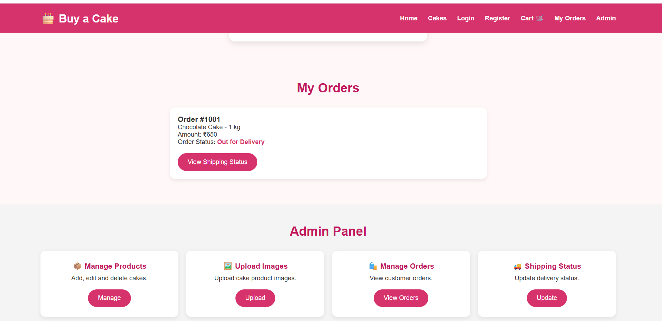

7. The online beauty parlour appointment booking system allows users to browse available services, view stylist profiles, and check appointment slots in real-time. Users can register, log in, and manage their appointments through a personal dashboard. The booking process includes selecting services, choosing a stylist, selecting a date and time, and making secure payments via an integrated payment gateway. Admins can manage service offerings, stylist schedules, and user accounts through a comprehensive admin panel. Users receive appointment confirmation emails and reminders, with the option to reschedule or cancel appointments through their dashboard. The website is fully responsive, ensuring an optimal experience on all devices. This website helps customers to search for any beauty parlour and book appointments as they preferable date and time.

Source Code:
<html lang="en">
<head>
<meta charset="UTF-8">
<meta name="viewport" content="width=device-width, initial-scale=1.0">
<title>Beauty Parlour Appointment Booking System</title>

<style>
*{
margin:0;
padding:0;
box-sizing:border-box;
font-family:Arial, sans-serif;
}

body{
background:#f6f3ff;
}

header{
background:#6a1b9a;
color:white;
text-align:center;
padding:25px;
}

nav{
background:#4a148c;
padding:15px;
text-align:center;
position:sticky;
top:0;
}

nav a{
color:white;
text-decoration:none;
margin:15px;
font-size:17px;
}

nav a:hover{
color:#ffd54f;
}

.hero{
background:#ede7f6;
text-align:center;
padding:70px 20px;
}

.hero h1{
color:#4a148c;
margin-bottom:10px;
}

.hero p{
color:#5e35b1;
font-size:18px;
}

.search{
width:90%;
max-width:950px;
background:white;
margin:25px auto;
padding:20px;
border-radius:12px;
box-shadow:0 4px 12px rgba(0,0,0,0.15);
}

form{
display:grid;
grid-template-columns:repeat(auto-fit,minmax(180px,1fr));
gap:15px;
}

input,select{
padding:12px;
font-size:15px;
border:1px solid #d1c4e9;
border-radius:6px;
}

button{
background:#7b1fa2;
color:white;
border:none;
padding:12px;
border-radius:6px;
cursor:pointer;
transition:0.3s;
}

button:hover{
background:#4a148c;
}

.section{
padding:35px;
}

.cards{
display:flex;
flex-wrap:wrap;
justify-content:center;
gap:20px;
}

.card{
width:240px;
background:white;
border-radius:12px;
box-shadow:0 3px 10px rgba(0,0,0,0.15);
text-align:center;
padding:18px;
transition:transform 0.3s;
}

.card:hover{
transform:translateY(-5px);
}

.card img{
width:100%;
height:160px;
object-fit:cover;
border-radius:10px;
}

.card h3{
color:#7b1fa2;
margin:10px 0;
}

.card p{
margin-bottom:10px;
}

textarea{
width:100%;
max-width:700px;
padding:12px;
border:1px solid #d1c4e9;
border-radius:8px;
}

.section ul{
line-height:2;
padding-left:20px;
}

footer{
background:#4a148c;
color:white;
text-align:center;
padding:18px;
margin-top:20px;
}
</style>
</head>

<body>

<header>
<h1>Beauty Parlour Appointment Booking System</h1>
<p>Book Your Beauty Appointment Online</p>
</header>

<nav>
<a href="#">Home</a>
<a href="#">Services</a>
<a href="#">Stylists</a>
<a href="#">Appointments</a>
<a href="#">Login</a>
<a href="#">Register</a>
<a href="#">Contact</a>
</nav>

<section class="hero">
<h1>Enhance Your Beauty with Expert Care</h1>
<p>Book Beauty Services Anytime, Anywhere</p>
</section>

<div class="search">
<h2>Book Your Appointment</h2>
<br>

<form>
<input type="text" placeholder="Customer Name">

<select>
<option>Select Service</option>
<option>Hair Cut</option>
<option>Hair Spa</option>
<option>Facial</option>
<option>Bridal Makeup</option>
<option>Pedicure</option>
<option>Manicure</option>
</select>

<select>
<option>Select Stylist</option>
<option>Priya</option>
<option>Anjali</option>
<option>Divya</option>
<option>Sneha</option>
</select>

<input type="date">
<input type="time">

<button type="submit">Book Appointment</button>
</form>
</div>

<section class="section">
<h2 align="center">Our Beauty Services</h2>
<br>

<div class="cards">

<div class="card">
<img src="https://images.pexels.com/photos/3992874/pexels-photo-3992874.jpeg?auto=compress&cs=tinysrgb&w=400" alt="Hair Styling">
<h3>Hair Styling</h3>
<p>Professional Hair Styling</p>
<button>Book Now</button>
</div>

<div class="card">
<img src="https://images.pexels.com/photos/3762879/pexels-photo-3762879.jpeg?auto=compress&cs=tinysrgb&w=400" alt="Facial">
<h3>Facial</h3>
<p>Skin Care Treatment</p>
<button>Book Now</button>
</div>

<div class="card">
<img src="https://images.pexels.com/photos/2113855/pexels-photo-2113855.jpeg?auto=compress&cs=tinysrgb&w=400" alt="Bridal Makeup">
<h3>Bridal Makeup</h3>
<p>Complete Bridal Package</p>
<button>Book Now</button>
</div>

<div class="card">
<img src="https://images.pexels.com/photos/3997379/pexels-photo-3997379.jpeg?auto=compress&cs=tinysrgb&w=400" alt="Manicure and Pedicure">
<h3>Manicure & Pedicure</h3>
<p>Nail Care Services</p>
<button>Book Now</button>
</div>

</div>
</section>

<section class="section">
<h2>Customer Features</h2>
<ul>
<li>✔ Register & Login</li>
<li>✔ View Services</li>
<li>✔ View Stylist Profiles</li>
<li>✔ Check Available Slots</li>
<li>✔ Book Appointment</li>
<li>✔ Reservation History</li>
<li>✔ Cancel or Reschedule Appointment</li>
<li>✔ Online Payment</li>
<li>✔ Personal Profile</li>
<li>✔ Leave Feedback</li>
</ul>
</section>

<section class="section">
<h2>Salon Manager Features</h2>
<ul>
<li>✔ Admin Login</li>
<li>✔ Reservation Calendar</li>
<li>✔ Manage Reservations</li>
<li>✔ Lock Unavailable Hours</li>
<li>✔ Manage Services & Stylists</li>
<li>✔ Send SMS Reminders</li>
<li>✔ Manage Customer Accounts</li>
<li>✔ Accept Online Payments</li>
</ul>
</section>

<section class="section">
<h2>Customer Feedback</h2>
<textarea rows="5" placeholder="Write your feedback here..."></textarea>
<br><br>
<button>Submit Feedback</button>
</section>

<section class="section">
<h2>Contact Us</h2>
<p><b>Email:</b> support@beautyparlour.com</p>
<p><b>Phone:</b> +1 9876543210</p>
<p><b>Address:</b> Beauty Parlour, Main Street</p>
</section>

<footer>
<p>© 2026 Beauty Parlour Appointment Booking System | All Rights Reserved</p>
</footer>

</body>
</html>
Output:
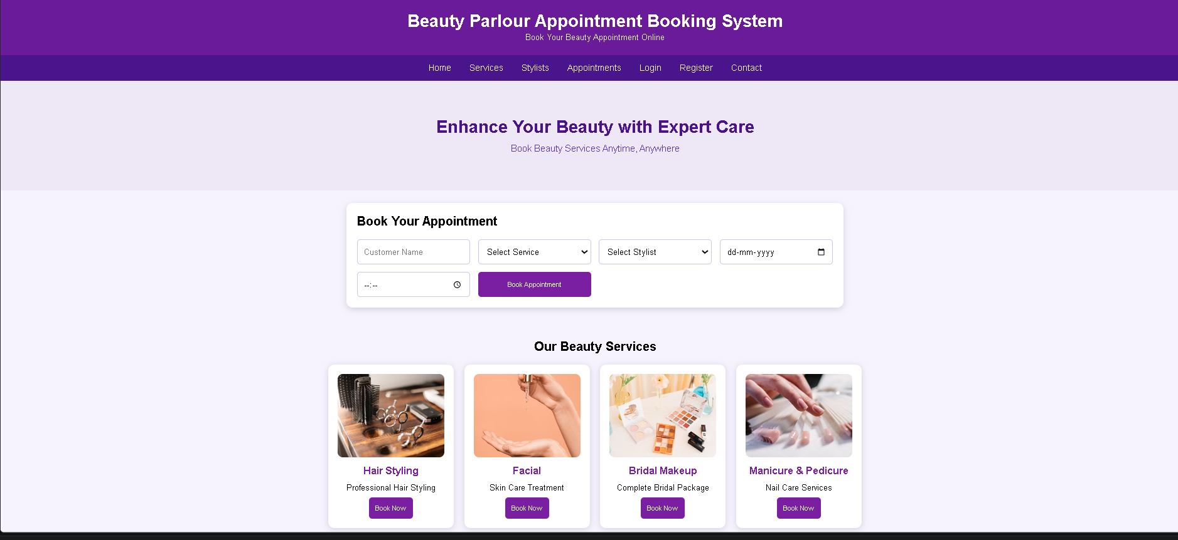

8. In an effort to streamline the appointment process and enhance patient experience, MedCare Hospital has developed an online appointment booking system. This platform allows patients to book appointments with doctors from various specialties at their convenience. Key functionalities include user registration and login, browsing available doctors and appointment slots, booking and canceling appointments, and receiving appointment reminders via email or SMS. Patients can also view their appointment history and update their personal details. The system ensures data security andcompliance with healthcare regulations to protect patient information. This online service aims to reduce wait times, minimize paperwork, and provide a seamless experience for patients and healthcare providers alike. This website helps the patient to search any hospital and book appointments as they prefer.
Source Code:
<!DOCTYPE html>
<html lang="en">
<head>
<meta charset="UTF-8">
<meta name="viewport" content="width=device-width, initial-scale=1.0">
<title>MedCare Hospital Appointment Booking</title>

<style>
*{
margin:0;
padding:0;
box-sizing:border-box;
font-family:Arial, sans-serif;
}

body{
background:#eef5fb;
}

header{
background:#0d6efd;
color:white;
text-align:center;
padding:25px;
}

nav{
background:#0b5ed7;
padding:15px;
text-align:center;
position:sticky;
top:0;
}

nav a{
color:white;
text-decoration:none;
margin:15px;
font-size:17px;
}

nav a:hover{
color:#ffd54f;
}

.hero{
background:#dbeafe;
padding:70px 20px;
text-align:center;
}

.hero h1{
color:#0b5ed7;
margin-bottom:10px;
}

.hero p{
color:#1e3a8a;
font-size:18px;
}

.search{
width:90%;
max-width:950px;
margin:25px auto;
background:white;
padding:20px;
border-radius:12px;
box-shadow:0 4px 12px rgba(0,0,0,0.15);
}

form{
display:grid;
grid-template-columns:repeat(auto-fit,minmax(180px,1fr));
gap:15px;
}

input,select{
padding:12px;
font-size:15px;
border:1px solid #cbd5e1;
border-radius:6px;
}

button{
background:#0d6efd;
color:white;
border:none;
padding:12px;
border-radius:6px;
cursor:pointer;
transition:0.3s;
}

button:hover{
background:#084298;
}

.section{
padding:35px;
}

.cards{
display:flex;
flex-wrap:wrap;
justify-content:center;
gap:20px;
}

.card{
width:240px;
background:white;
padding:18px;
border-radius:12px;
box-shadow:0 3px 10px rgba(0,0,0,0.15);
text-align:center;
transition:transform 0.3s;
}

.card:hover{
transform:translateY(-5px);
}

.card img{
width:100%;
height:180px;
object-fit:cover;
border-radius:10px;
margin-bottom:10px;
}

.card h3{
color:#0d6efd;
margin-bottom:8px;
}

.card p{
margin-bottom:6px;
}

textarea{
width:100%;
max-width:700px;
padding:12px;
border:1px solid #cbd5e1;
border-radius:8px;
}

.section ul{
line-height:2;
padding-left:20px;
}

footer{
background:#0b5ed7;
color:white;
text-align:center;
padding:18px;
margin-top:20px;
}
</style>
</head>

<body>

<header>
<h1>MedCare Hospital Appointment Booking System</h1>
<p>Book Doctor Appointments Online</p>
</header>

<nav>
<a href="#">Home</a>
<a href="#">Hospitals</a>
<a href="#">Doctors</a>
<a href="#">Appointments</a>
<a href="#">Login</a>
<a href="#">Register</a>
<a href="#">Contact</a>
</nav>

<section class="hero">
<h1>Find the Right Doctor for Your Health</h1>
<p>Search Hospitals and Book Appointments Easily</p>
</section>

<div class="search">
<h2>Search Doctor</h2>
<br>

<form>
<input type="text" placeholder="Enter Location">

<select>
<option>Select Specialty</option>
<option>Cardiologist</option>
<option>Dermatologist</option>
<option>Orthopedic</option>
<option>Pediatrician</option>
<option>Neurologist</option>
</select>

<input type="date">

<button type="submit">Search</button>
</form>
</div>

<section class="section">
<h2 align="center">Available Doctors</h2>
<br>

<div class="cards">

<div class="card">
<img src="https://images.pexels.com/photos/5327585/pexels-photo-5327585.jpeg?auto=compress&cs=tinysrgb&w=400" alt="Dr. John Smith">
<h3>Dr. John Smith</h3>
<p>Cardiologist</p>
<p>City Hospital</p>
<button>Book Appointment</button>
</div>

<div class="card">
<img src="https://images.pexels.com/photos/5214997/pexels-photo-5214997.jpeg?auto=compress&cs=tinysrgb&w=400" alt="Dr. Priya Sharma">
<h3>Dr. Priya Sharma</h3>
<p>Dermatologist</p>
<p>MedCare Hospital</p>
<button>Book Appointment</button>
</div>

<div class="card">
<img src="https://images.pexels.com/photos/5452293/pexels-photo-5452293.jpeg?auto=compress&cs=tinysrgb&w=400" alt="Dr. David Lee">
<h3>Dr. David Lee</h3>
<p>Orthopedic</p>
<p>Sunrise Hospital</p>
<button>Book Appointment</button>
</div>

<div class="card">
<img src="https://images.pexels.com/photos/5998470/pexels-photo-5998470.jpeg?auto=compress&cs=tinysrgb&w=400" alt="Dr. Anjali Rao">
<h3>Dr. Anjali Rao</h3>
<p>Pediatrician</p>
<p>LifeCare Hospital</p>
<button>Book Appointment</button>
</div>

</div>
</section>

<section class="section">
<h2>Patient Features</h2>
<ul>
<li>✔ Signup / Login</li>
<li>✔ Search Doctors by Specialty</li>
<li>✔ Search Hospitals by Location</li>
<li>✔ Book Appointment</li>
<li>✔ Cancel Appointment</li>
<li>✔ Appointment History</li>
<li>✔ View Appointment Status</li>
<li>✔ Update Personal Details</li>
<li>✔ View Hospital Location</li>
<li>✔ Rate and Review Doctors</li>
</ul>
</section>

<section class="section">
<h2>Hospital Features</h2>
<ul>
<li>✔ Hospital Registration</li>
<li>✔ Hospital Login</li>
<li>✔ Create Hospital Profile</li>
<li>✔ Update Hospital Details</li>
<li>✔ Manage Doctors</li>
<li>✔ Manage Appointments</li>
</ul>
</section>

<section class="section">
<h2>Administrator Features</h2>
<ul>
<li>✔ Manage Doctors</li>
<li>✔ Manage Appointments</li>
<li>✔ Appointment Statistics</li>
<li>✔ Rating Details</li>
<li>✔ Manage Hospitals</li>
<li>✔ Manage Patients</li>
</ul>
</section>

<section class="section">
<h2>Patient Feedback</h2>
<textarea rows="5" placeholder="Write your review here..."></textarea>
<br><br>
<button>Submit Review</button>
</section>

<section class="section">
<h2>Contact Us</h2>
<p><b>Email:</b> support@medcarehospital.com</p>
<p><b>Phone:</b> +1 9876543210</p>
<p><b>Address:</b> MedCare Hospital, Main City</p>
</section>

<footer>
<p>© 2026 MedCare Hospital Appointment Booking System | All Rights Reserved</p>
</footer>

</body>
</html>
Output:
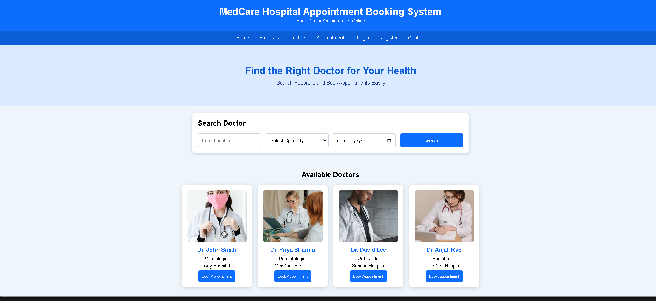
9. TechSavvy, a leading retailer of electronic gadgets, has launched an online shopping platform to provide customers with a seamless and convenient shopping experience. The website features a wide range of products, including smartphones, laptops, tablets, and accessories, all categorized for easy browsing. Key functionalities include user registration and login, product search and filtering, detailed product descriptions and reviews, secure payment options, and order tracking. Customers can add items to their cart, create wish lists, and receive personalized recommendations based on their browsing and purchase history. The platform also offers exclusive online discounts and promotions, ensuring customers get the best deals on the latest gadgets.The core of an online shop is the product catalogue and the cart. The users browse products which are grouped incategories and add the desired ones to the cart. Next, there is transactionhandling, which in its simplest form consists in the order being sent via e-mail to the seller, butmost often it takes the whole buying process through separate order statuses.
Source Code:
<!DOCTYPE html>
<html lang="en">
<head>
<meta charset="UTF-8">
<meta name="viewport" content="width=device-width, initial-scale=1.0">
<title>TechSavvy Online Shopping</title>

<style>
*{
margin:0;
padding:0;
box-sizing:border-box;
font-family:Arial, sans-serif;
}

body{
background:#eef3f8;
}

header{
background:#0b1f3a;
color:white;
text-align:center;
padding:25px;
}

nav{
background:#133b6b;
text-align:center;
padding:15px;
}

nav a{
color:white;
text-decoration:none;
margin:15px;
font-size:17px;
}

nav a:hover{
color:#ffd54f;
}

.hero{
background:#dbeafe;
text-align:center;
padding:70px 20px;
}

.hero h1{
color:#0b1f3a;
margin-bottom:10px;
}

.hero p{
color:#1e3a8a;
font-size:18px;
}

.search{
width:90%;
max-width:1000px;
background:white;
margin:25px auto;
padding:20px;
border-radius:12px;
box-shadow:0 4px 12px rgba(0,0,0,0.15);
}

form{
display:grid;
grid-template-columns:repeat(auto-fit,minmax(180px,1fr));
gap:15px;
}

input,select{
padding:12px;
border:1px solid #ccc;
border-radius:8px;
}

button{
background:#0b5ed7;
color:white;
border:none;
padding:12px;
border-radius:8px;
cursor:pointer;
}

button:hover{
background:#084298;
}

.section{
padding:40px 20px;
}

.section h2{
text-align:center;
color:#133b6b;
margin-bottom:30px;
}

.cards{
display:grid;
grid-template-columns:repeat(auto-fit,minmax(220px,1fr));
gap:25px;
max-width:1100px;
margin:auto;
}

.card{
background:white;
border-radius:15px;
overflow:hidden;
box-shadow:0 5px 15px rgba(0,0,0,0.12);
transition:0.3s;
text-align:center;
}

.card:hover{
transform:translateY(-6px);
}

.card img{
width:100%;
height:180px;
object-fit:cover;
}

.card h3{
color:#0b5ed7;
margin:15px 0 8px;
}

.card p{
margin-bottom:15px;
}

.card button{
margin-bottom:18px;
}

.features{
max-width:1000px;
margin:auto;
display:grid;
grid-template-columns:1fr 1fr;
gap:25px;
}

.feature-box{
background:white;
padding:25px;
border-radius:15px;
box-shadow:0 4px 12px rgba(0,0,0,0.12);
}

.feature-box h3{
color:#133b6b;
margin-bottom:15px;
}

.feature-box ul{
line-height:2;
padding-left:20px;
}

.review{
max-width:800px;
margin:auto;
text-align:center;
}

.review textarea{
width:100%;
padding:15px;
border:1px solid #ccc;
border-radius:10px;
margin-bottom:15px;
}

.contact{
text-align:center;
line-height:2;
}

footer{
background:#0b1f3a;
color:white;
text-align:center;
padding:20px;
margin-top:30px;
}

@media(max-width:768px){
.features{
grid-template-columns:1fr;
}
}
</style>
</head>

<body>

<header>
<h1>TechSavvy Online Shopping</h1>
<p>Electronics Shopping Made Easy</p>
</header>

<nav>
<a href="#">Home</a>
<a href="#">Products</a>
<a href="#">Categories</a>
<a href="#">Cart</a>
<a href="#">Wishlist</a>
<a href="#">Login</a>
<a href="#">Register</a>
<a href="#">Contact</a>
</nav>

<section class="hero">
<h1>Latest Electronic Gadgets</h1>
<p>Smartphones • Laptops • Tablets • Accessories</p>
</section>

<div class="search">
<h2>Search Products</h2>
<br>

<form>
<input type="text" placeholder="Search Product">

<select>
<option>All Categories</option>
<option>Smartphones</option>
<option>Laptops</option>
<option>Tablets</option>
<option>Headphones</option>
<option>Smart Watches</option>
</select>

<select>
<option>Price Range</option>
<option>Under $100</option>
<option>$100 - $500</option>
<option>$500 - $1000</option>
<option>Above $1000</option>
</select>

<button type="submit">Search</button>
</form>
</div>

<section class="section">
<h2>Popular Products</h2>

<div class="cards">

<div class="card">
<img src="https://images.pexels.com/photos/607812/pexels-photo-607812.jpeg?auto=compress&cs=tinysrgb&w=400" alt="Smartphone">
<h3>Smartphone</h3>
<p><strong>Price: $699</strong></p>
<button>Add to Cart</button>
</div>

<div class="card">
<img src="https://images.pexels.com/photos/18105/pexels-photo.jpg?auto=compress&cs=tinysrgb&w=400" alt="Laptop">
<h3>Laptop</h3>
<p><strong>Price: $999</strong></p>
<button>Add to Cart</button>
</div>

<div class="card">
<img src="https://images.pexels.com/photos/1334597/pexels-photo-1334597.jpeg?auto=compress&cs=tinysrgb&w=400" alt="Tablet">
<h3>Tablet</h3>
<p><strong>Price: $499</strong></p>
<button>Add to Cart</button>
</div>

<div class="card">
<img src="https://images.pexels.com/photos/3394650/pexels-photo-3394650.jpeg?auto=compress&cs=tinysrgb&w=400" alt="Wireless Headphones">
<h3>Wireless Headphones</h3>
<p><strong>Price: $149</strong></p>
<button>Add to Cart</button>
</div>

</div>
</section>

<section class="section">
<div class="features">

<div class="feature-box">
<h3>Customer Features</h3>
<ul>
<li>User Registration & Login</li>
<li>Search Products</li>
<li>Browse Categories</li>
<li>Check Product Availability</li>
<li>View Product Details</li>
<li>Add to Cart</li>
<li>Wishlist</li>
<li>Checkout & Order Tracking</li>
</ul>
</div>

<div class="feature-box">
<h3>Administrator Features</h3>
<ul>
<li>Admin Login</li>
<li>Add & Remove Products</li>
<li>Update Prices & Descriptions</li>
<li>Manage Categories</li>
<li>View Customer Orders</li>
<li>Generate Reports</li>
<li>Inventory Management</li>
</ul>
</div>

</div>
</section>

<section class="section review">
<h2>Customer Reviews</h2>
<textarea rows="5" placeholder="Write your review here..."></textarea>
<br>
<button>Submit Review</button>
</section>

<section class="section contact">
<h2>Contact Us</h2>
<p><strong>Email:</strong> support@techsavvy.com</p>
<p><strong>Phone:</strong> +1 9876543210</p>
<p><strong>Address:</strong> TechSavvy Electronics Store</p>
</section>

<footer>
<p>© 2026 TechSavvy Online Shopping | All Rights Reserved</p>
</footer>

</body>
</html>
Output:
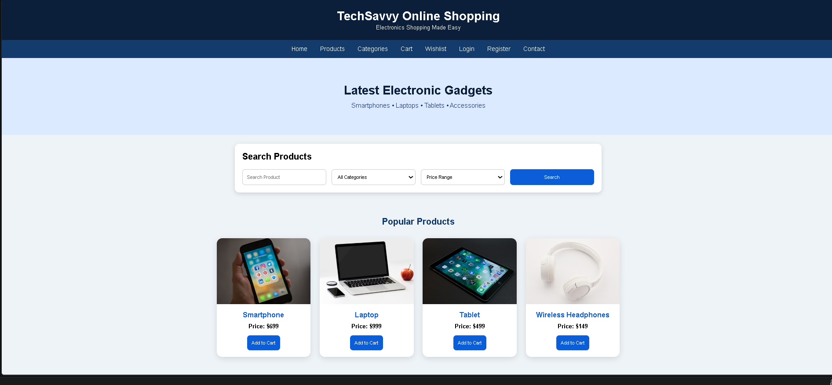

10. StyleHub, a premier online fashion retailer, introduces its comprehensive e-commerce platform designed to cater to fashion enthusiasts. The website offers an extensive collection of clothing, footwear, and accessories for men, women, and children, with categories such as casual wear, formal attire, and seasonal collections. Key functionalities include user registration and login, advanced search and filtering options, detailed product descriptions with high-resolution images, customer reviews, and size guides. The platform supports secure payment methods, order tracking, and an easy return and exchange policy. Customers can create wish lists, receive personalized style recommendations, and enjoy exclusive online discounts and flash sales. StyleHub aims to provide a seamless and enjoyable shopping experience, keeping users up-to-date with the latest fashion trends.The core of an online shop is the product catalogue and the cart. The users browse products which are grouped in categories and add the desired ones to the cart. Next, there is transaction handling, which in its simplest form consists in the order being sent via e-mail to the seller, but most often it takes the whole buying process through separate order statuses.
Source Code:
<!DOCTYPE html>
<html lang="en">
<head>
<meta charset="UTF-8">
<meta name="viewport" content="width=device-width, initial-scale=1.0">
<title>StyleHub - Online Fashion Store</title>

<style>
*{
margin:0;
padding:0;
box-sizing:border-box;
font-family:Arial, Helvetica, sans-serif;
}

body{
background:#f8f5fb;
color:#333;
}

header{
background:#6a1b9a;
color:white;
text-align:center;
padding:25px;
}

nav{
background:#4a148c;
text-align:center;
padding:15px;
position:sticky;
top:0;
}

nav a{
color:white;
text-decoration:none;
margin:15px;
font-size:17px;
}

nav a:hover{
color:#ffd54f;
}

.hero{
background:#ede7f6;
text-align:center;
padding:70px 20px;
}

.hero h1{
color:#4a148c;
font-size:38px;
margin-bottom:10px;
}

.hero p{
color:#6a1b9a;
font-size:18px;
}

.search-box{
width:90%;
max-width:1000px;
margin:30px auto;
background:white;
padding:25px;
border-radius:15px;
box-shadow:0 5px 15px rgba(0,0,0,0.15);
}

.search-box h2{
color:#4a148c;
margin-bottom:15px;
}

form{
display:grid;
grid-template-columns:repeat(auto-fit,minmax(180px,1fr));
gap:15px;
}

input,select{
padding:12px;
border:1px solid #ccc;
border-radius:8px;
font-size:15px;
}

button{
background:#8e24aa;
color:white;
border:none;
padding:12px;
border-radius:8px;
cursor:pointer;
transition:0.3s;
}

button:hover{
background:#4a148c;
}

.section{
padding:40px 20px;
}

.section h2{
text-align:center;
color:#4a148c;
margin-bottom:30px;
}

.cards{
display:grid;
grid-template-columns:repeat(auto-fit,minmax(220px,1fr));
gap:25px;
max-width:1100px;
margin:auto;
}

.card{
background:white;
border-radius:15px;
overflow:hidden;
box-shadow:0 5px 15px rgba(0,0,0,0.12);
transition:transform 0.3s;
text-align:center;
}

.card:hover{
transform:translateY(-8px);
}

.card img{
width:100%;
height:250px;
object-fit:cover;
}

.card-content{
padding:18px;
}

.card h3{
color:#8e24aa;
margin-bottom:10px;
}

.card p{
margin-bottom:15px;
}

.features{
max-width:1100px;
margin:auto;
display:grid;
grid-template-columns:1fr 1fr;
gap:25px;
}

.feature-box{
background:white;
padding:25px;
border-radius:15px;
box-shadow:0 5px 12px rgba(0,0,0,0.12);
}

.feature-box h3{
color:#6a1b9a;
margin-bottom:15px;
}

.feature-box ul{
line-height:2;
padding-left:20px;
}

.review{
max-width:800px;
margin:auto;
text-align:center;
}

.review textarea{
width:100%;
padding:15px;
border:1px solid #ccc;
border-radius:10px;
margin-bottom:15px;
}

.contact{
text-align:center;
line-height:2;
}

footer{
background:#4a148c;
color:white;
text-align:center;
padding:20px;
margin-top:30px;
}

@media(max-width:768px){
.features{
grid-template-columns:1fr;
}
}
</style>
</head>

<body>

<header>
<h1>StyleHub Fashion Store</h1>
<p>Shop the Latest Fashion Trends</p>
</header>

<nav>
<a href="#">Home</a>
<a href="#">Men</a>
<a href="#">Women</a>
<a href="#">Kids</a>
<a href="#">Accessories</a>
<a href="#">Cart</a>
<a href="#">Wishlist</a>
<a href="#">Login</a>
<a href="#">Register</a>
</nav>

<section class="hero">
<h1>Fashion for Everyone</h1>
<p>Clothing • Footwear • Accessories</p>
</section>

<div class="search-box">
<h2>Search Products</h2>

<form>
<input type="text" placeholder="Search Product">

<select>
<option>Select Category</option>
<option>Men</option>
<option>Women</option>
<option>Kids</option>
<option>Accessories</option>
</select>

<select>
<option>Select Price</option>
<option>Under $50</option>
<option>$50 - $100</option>
<option>$100 - $200</option>
<option>Above $200</option>
</select>

<button type="submit">Search</button>
</form>
</div>

<section class="section">
<h2>Popular Categories</h2>

<div class="cards">

<div class="card">
<img src="https://images.pexels.com/photos/1043474/pexels-photo-1043474.jpeg?auto=compress&cs=tinysrgb&w=400" alt="Men's Wear">
<div class="card-content">
<h3>Men's Wear</h3>
<p>Casual & Formal Collection</p>
<button>Shop Now</button>
</div>
</div>

<div class="card">
<img src="https://images.pexels.com/photos/994523/pexels-photo-994523.jpeg?auto=compress&cs=tinysrgb&w=400" alt="Women's Wear">
<div class="card-content">
<h3>Women's Wear</h3>
<p>Latest Fashion Trends</p>
<button>Shop Now</button>
</div>
</div>
<div class="card">
<img src="https://images.pexels.com/photos/1620760/pexels-photo-1620760.jpeg?auto=compress&cs=tinysrgb&w=400" alt="Kids Fashion">
<div class="card-content">
<h3>Kids Fashion</h3>
<p>Comfortable & Stylish</p>
<button>Shop Now</button>
</div>
</div>
<div class="card">
<img src="https://images.pexels.com/photos/934070/pexels-photo-934070.jpeg?auto=compress&cs=tinysrgb&w=400" alt="Accessories">
<div class="card-content">
<h3>Accessories</h3>
<p>Bags, Watches & More</p>
<button>Shop Now</button>
</div>
</div>
</div>
</section>
<section class="section">
<div class="features">

<div class="feature-box">
<h3>Customer Features</h3>
<ul>
<li>User Registration & Login</li>
<li>Browse Products</li>
<li>Search & Filter Products</li>
<li>View Product Details</li>
<li>Shopping Cart</li>
<li>Wishlist</li>
<li>Secure Checkout</li>
<li>Track Orders</li>
<li>Order History</li>
<li>Returns & Exchange</li>
</ul>
</div>

<div class="feature-box">
<h3>Administrator Features</h3>
<ul>
<li>Admin Login</li>
<li>Add & Remove Products</li>
<li>Update Prices</li>
<li>Manage Categories</li>
<li>Manage Customer Orders</li>
<li>Customer Management</li>
<li>Discount & Offer Management</li>
<li>Sales Reports</li>
</ul>
</div>

</div>
</section>

<section class="section review">
<h2>Customer Reviews</h2>
<textarea rows="5" placeholder="Write your review here..."></textarea>
<br>
<button>Submit Review</button>
</section>
<section class="section contact">
<h2>Contact Us</h2>
<p><strong>Email:</strong> support@stylehub.com</p>
<p><strong>Phone:</strong> +1 9876543210</p>
<p><strong>Address:</strong> StyleHub Fashion Store</p>
</section>
<footer>
<p>© 2026 StyleHub Online Fashion Store | All Rights Reserved</p>
</footer>
</body>
</html>
Output:
